

Student

Management

System

**Manage students efficiently with an all-in-one system.**

Details of work done by group members:

Cover page, 1st, 2nd and 3rd sections are done by **Paras.**

4th and 9th (diagram)explained by **Prabhjot Singh**

5th and 6th sections are written by **Harpreet kaur**.

7th and 8th sections are done by **Gursehbaj**

Table of content

Section 1: System Idea in a Nutshell 4

Section 2: Story Behind the Idea 4

Section 3: Information offered to the user 4

Section 4: Data stored By The System 4

Section 5: WHERE IS THE DATA COMING from ? 4

Section 6: TARGET Users 4

Section 7: SIMILAR SYSTEM 5

Section 8: BENEFITS to the Users 5

Section 9: diagram and visual design 5

# Section 1: System Idea in a Nutshell

The **University Student Management Database System** (USMDS) is a **user-friendly** platform that will assist academic staff to store and organize student’s information easily in **one place**.



We understand that how challenging it is, to store the information of the thousands of students and update it frequently when it is required.

After studied existed Student Management Databases, we came up with the idea to create a new database that will not only helps in **reducing** the **administrative task**s performed by the academic staff such as student’s grades, attendance, records, course registration and many more, but also helps students to manage their profiles along with the high level of security.

Apart from that, with the assistance of this database, it will also become **easier** to **update** the student’s information frequently in a swift manner.

# Section 2: Story Behind the Idea

Everybody is familiar with the topic of Student Management System; still academic staff finds it a stressful task to gather information of plenty of students and keep a track on their profile. Despite of having enough knowledge about **SMS** (Student Management System), many universities need extra staff members to manage the student information effectively. The one vital reason for this is the **increment** of number of **students per university**.

Even students sometimes finds it complicated task to get the crucial information about their studies, such as deadlines, announcements, grades, communicate with their professors and more, just because of the scattered information on different portfolios.



Therefore, to tackle such a problems, me and my team members decided to design a database that can handle all **aspects** of student management, such as from enrolment and course registration to keep an eye on academic performance and managing various complicated administrative tasks.

We think that this database would be **fruitful** for the academic institutes as well as students to deal with vast number of students and their information sufficiently and effectively.

# Section 3: Information offered to the user

Our system will offer complete information for the students as well as staff members of the college or university to enhance the overall experience of studies.

 **For students**, the system will offer all the personal details of the students such as name, date of birth, gender, address, contact information, email address. Some other details from academic side like student ID, enrollment status, course subjects (major,minor),classes schedules, grades, attendance records which will help student to get the all necessary information during study time.

**For academic staff**, this system will not assist students to manage their information, but will also becomes handy for the academic staff members. With the help of this database staff members can keep tracks on student’s performance by checking the student’s grades, so that they can assist those students who are struggling with studies by providing them extra support. Also, professors can set their class schedules and can update it whenever it is required to match with their time table.

**For administrators,** this database will also helps admin to deal with large number of students profiles effectively. Also, assist them to store records of fee payments, scholarship offered to the students and health insurance and more without facing any troubles at one place.

Overall, this system will provide sufficient information to the users in order to make the whole process **smoother** and **effective**.

**Personal Information:**

* **Full Name**
* **Date of Birth**
* **Gender**
* **Address**
* **Contact Information**

**Academic Information :**

* **Student ID**
* **Enrollment status**
* **Program of Study**
* **Grades**
* **Attendance Records**
* **Academic Advisor**

**Administrative Information:**

* **Tuition Fees**
* **Scholarships**
* **Financial Aid**
* **Health insurance detail**

# 

# Section 4: Data stored By The System

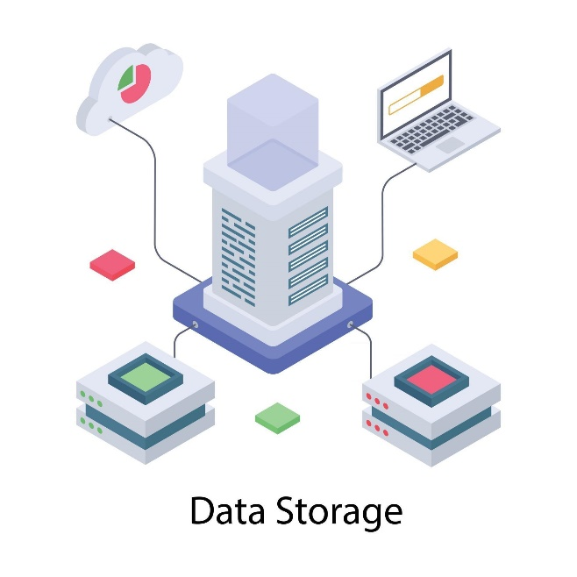

The university student Management database system (USMDS) is designed to store a comprehensive

Range of information related to students, faculty and academic activities. The type of data stored

Include:

Personal Information:

* Basic Details: Name, Gender, date of birth, Ethnicity, Injuries or disabilities and medical conditions details.
* Contact information: Phone numbers, email address, study address and permanent addresses.
* Identity Documentation: Scanned copies of government-issued IDs (passport, national ID card, etc), Student ID numbers
* Emergency Contacts: Detailed information about guardians or emergency contacts, Including their relationships to the student, phone numbers, and addresses.
* Academic Information:
* Enrolment Details: Enrolment Number, date of enrolment, Current academic status (e.g. active, on leave, graduated), and program of study (Major/Minor).
* Course information: Detailed list of all current and past courses, including course codes, titles, instructors, schedules and grade.
* Academic History: Records of past academic Performance, including transcripts, GPA, class rank and academic awards or honours.
* Class Schedules: Timetable For classes, including dates, times and locations
* Behavioural Records:
* Disciplinary Actions: Detailed records of any disciplinary actions taken against the student, including the nature of the offense, date and outcomes.
* Behavioural Notes: Observations or remarks regarding a student's conduct and behaviour, both positive and negative, as recorded by instructors or administrators.
* Health and wellness information:
* Medical Records: Comprehensive medical documentation, including allergies, chronic conditions, immunization records and any special medical needs.
* Counselling Records: Notes from any counselling sessions, mental health evaluations and referrals (subject to privacy and legal regulations).
* Health Insurance: Information about health insurance provided by the university, including policy numbers, coverage details and expiration dates.
* Financial Information:
* Tuition and Fees: Detailed records of tuition fees, payments, outstanding balances and payment plans.
* Financial Aid: Information on scholarships, grants, loans and other financial aid received by the student, including application status and disbursement records.
* Work-Study Programs: Details of participation in work-study programs, including job assignments, hours worked and earnings.
* Guardian and family information:
* Parent/Guardian Details: Names, Contact information, occupation Relationship.

Section 5: WHERE IS THE DATA COMING from ?

Student data in a student management system typically comes from a variety of sources , including:

**FORMATS FOR ENROLMENT**

**Application Form**: Information gleaned from students’ personal and academic

histories during the application process.

**Registration form**: Data gathered when students formally enroll in a course or program,

including demographics and contact information.

**MANAGEMENT RECORDS**

**Registration Office**: Data collected from administrative staff to help choose courses and make record modifications during the registration process.

**Academic affairs** : Information regarding program changes , grades reports and academic advancement.

**Academic Records**: Data kept by course management systems about enrolment, grades attendance and performance in classes . Information from tests, grading and evaluations is contained in exam records.

**STAFF ENTRY AND AUTHORITY**

Feedback from instructors consists of remarks, assessments and grades.

**Staff Contributions**: Administration updates and makes changes to student data .

**Medical and counselling records:** Details pertaining to medical and counselling services, as allowed under privacy laws , if relevant .

**MANAGEMENT OF RESOURCES AND LIBRARY**

**Library checkouts** : A list of the resources and books that the pupils have borrowed . Details regarding the use of academic resources and facilities.

**DATA FINANCIAL**

**Fee payment details:** The finance office provides information on tuition , scholarship and financial features and functionality of the system . Still , a few of the main target audiences are usually as follows aid .

**Financial aid applications:** Information gathered from loan and grant applications as well as scholarship applications .

**Records of communications SURVEYS:** Information gathered via questionnaries feedback forms for students.

# Section 6: TARGET Users

A university student management system (USMS) can change based on the features and

functionality of the system. However , some of the primary target audience are usually as follows



**STUDENTS**

The main users of the system are students who utilize it to access their personal data , grades schedules

and communications from their school .

**TEACHERS & INSTRUCTORS**

Teachers and instructors use the system to enter grades , monitor student progress , record attendance and communicate with parents and other stakeholders.

**EMPLOYEES IN ADMINSTRATION**

In addition to processing admissions , maintaining student data producing reports , the administrative staff oversees the day – to day functioning of the system.

**COLLEGE ADMINISTRATION**

Principals , deans and other upper-level administrators make strategic decisions , evaluate performance indicators and supervise all aspects of school operations using the system in school/college management .

**IT SUPPORT EMPLOYEES**

They are responsible for maintaining the functionality of the system , handling issues , and safeguarding data .

**ACADEMIC AND COUNSELLING ADVISORS**

Counselors and academic advisors use the system to assist students with course selection , track their academic progress and provide career guidance.

Every one of these users interacts with the system differently and requires distinct features and access levels in order to fulfil their assigned obligations.

Section 7: SIMILAR SYSTEM

There are several similar projects or systems which can solve some of the problems faced by the students and staff to manage the data, but all these systems have limited features.

For instance, there is a system called Student information system here the system is limited to managing only the student information and not provide ultimate help to staff and administration.

Similarly, the other systems which are like our system to some extent, but all have limited features.

Some of the most used system in this field are shown below:

* Campus Management System
* Learning Management System
* Academic Management System
* Education Management Information System
* Enrollment management System
* Faculty Management System
* Course Management System

# Section 8: BENEFITS to the Users

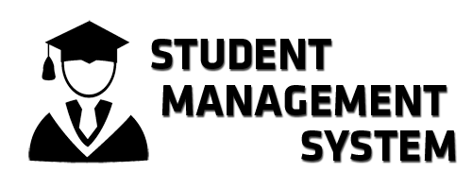

Our system will be beneficial for students as well as the staff members in different aspects of managing the data of students. This will ultimately solve several problems faced by students, staff members and administrators.

**Benefits for Students:**

For students, our system will offer easy access to their personal data and the academic planning. In which students will be able to check their information, the academic records and enrolment information in one place.

With our system student can plan their academic path more effectively with up-to-date information. Student will get needed support according to their progress tracked by the staff in this system.

**Benefits for Administration:**

Apart from this, our system will play a predominant role in managing administrative processes which will ultimately help staff and lighten their burden. This will make the task of storing students data easier.

Our database system will provide enhanced data security by which no unauthorized person can access students data.

Another major thing is that the paperwork as well as the manual labour will be reduced. Which will ultimately save the time and resources.

**Benefits for Staff:**

Staff can be also able to manage course information, grades and enrolment details in a single system. It will also improve the accuracy and consistency across the institute regarding every aspect.

It enables staff to provide better support to the students for improving their overall experience. Our system also allows the better allocation of the data.

# Section 9: diagram and visual design

